|  |
| --- |
| Circle Language Spec: Execution Control |

## If in a Diagram

The concept of the If statement is already covered in the article *If*. This article only explains its expression in a diagram.

The If Then statement takes a Boolean condition and a reference to the command to run when the Boolean is True.

In a diagram this looks as follows.

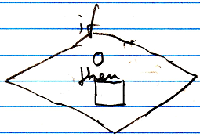

The circle is the Boolean condition. The square is the command to execute when the Boolean condition is True.

The Then command can be defined right inside the call to the If statement, but you can also define the Then *outside* the If with the aid of an esteatic reference:

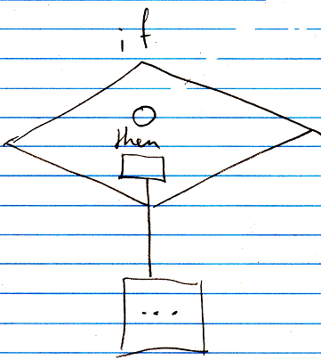

The Boolean condition is usually defined elsewhere as well, which will make the condition a pointer to another symbol.

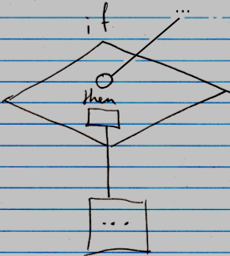

The If Else statement takes a Boolean condition, a command reference to the command to run when the Boolean is True and a command reference to the command to run when the Boolean is False.

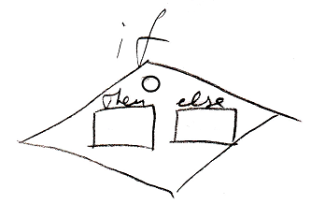

The circle is the Boolean condition. The square named Then is the command to execute when the Boolean condition is True. The square named Else is the command to execute when the Boolean condition is False. For the If Else statement, the Then and Else are also usually defined *outside* the If with the aid of an esteatic reference:

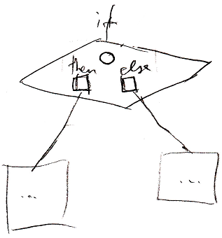

And the condition is usally defined elsewhere as well:

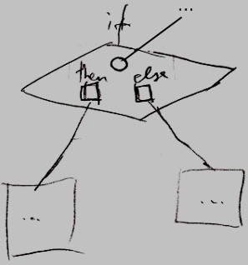

The definition of the If execution control command is part of a system module of execution control command. The public elements of the definition look like this:

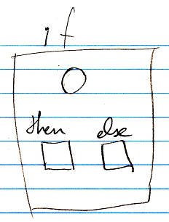

In the definition, the condition and the clauses are not filled in yet.